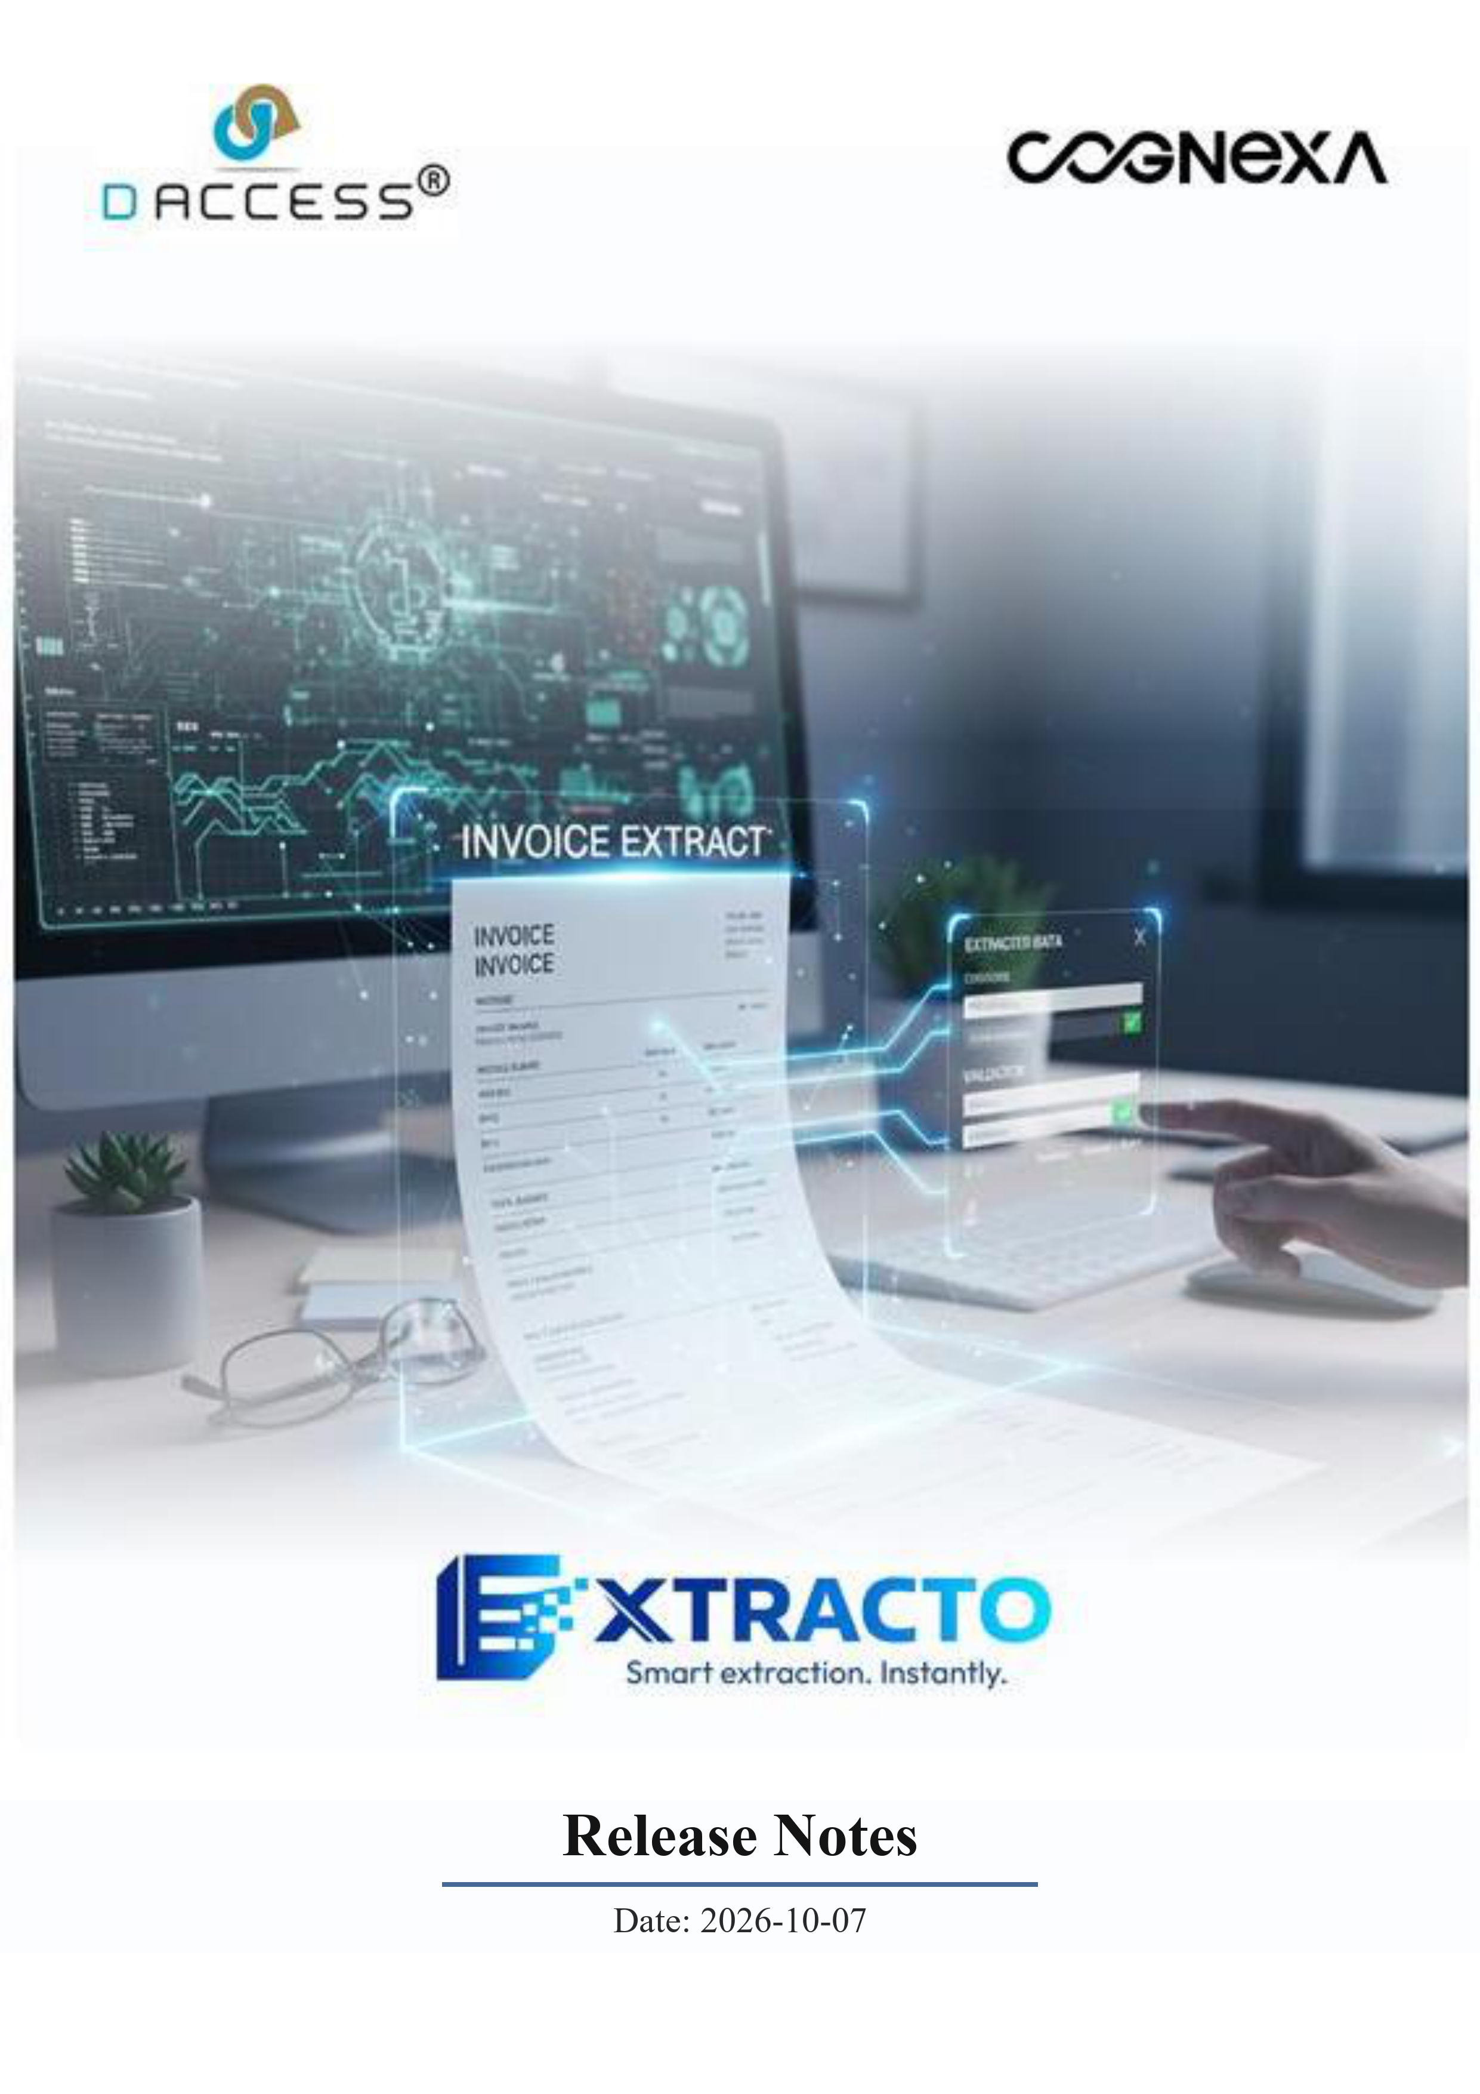

Welcome to Extracto Cloud
Extracto Cloud is your gate-to-ledger challan and vehicle-document capture system. Photograph a challan or vehicle, and the Cloud Backend reads it with Azure AI Document Intelligence and extracts structured data with Azure OpenAI (GPT-4o), so your team reviews a clean form instead of a handwritten slip. Every extraction is tracked from capture through approval, master data is kept in one place, and dashboards show exactly how the pipeline is performing. This is our first release, and it already covers everything you need to run day-to-day inward/outward document processing with confidence.

What This Product Does
When a challan or vehicle photo is uploaded from Extracto Web or the Extracto Tab kiosk, the Cloud Backend runs OCR (Azure Document Intelligence) over the image and passes the text and the image together to Azure OpenAI's vision model, which returns the structured fields — vendor, vehicle number, quantities, dates and more. A reviewer can correct any field before deciding to Approve or Reject, or can skip OCR entirely and key in a Manual Entry. Approved records flow into History, Dashboard figures, Analytics and Reports; vendors, warehouses, transporters and materials used by extraction are kept current from one shared Master Data screen.
Each person sees only what their role allows. Admins manage everything, including who can see or edit each section. Everyone else gets exactly the sections their role grants under RBAC — nothing more.

Key Features

Running Extraction Automatically
- Smart Capture — Upload a challan or up to two vehicle photos (front/back) from Extracto Web or the Extracto Tab kiosk — no manual form by default.
- OCR + AI Extraction — Azure Document Intelligence reads the raw text; Azure OpenAI (GPT-4o) turns that text and the image into structured fields in one pass.
- Manual Entry Fallback — Any record can be keyed in by hand when a photo isn't available or OCR confidence is low.
- Review Before It Counts — Every extracted field is editable before you Approve or Reject — nothing is written to History unreviewed.
- Master Data, One Place — Vendors, Warehouses, Transporters and Materials are managed centrally and reused across every extraction.

Watching the Work Happen
- Dashboard — At-a-glance figures for today's uploads, approvals, rejections and pending reviews.
- Analytics & Reports — Trends across time, vendors and locations, exportable to Excel and PDF.
- History — Every extraction and manual entry record, searchable and filterable, with full before/after detail on each one.
- Audit Logs — Sign-ins, approvals, rejections and record/setting changes are all logged against the person who made them.

Keeping Control
- Secure Sign-In — Email + password sign-in with short-lived access tokens and an httpOnly refresh-token cookie; a rate limiter blocks brute-force login attempts.
- Role-Based Access (RBAC) — Four roles — Admin, User, Security, Other — each with per-section View / Create / Edit / Delete, managed from RBAC Master. Admin accounts are protected from accidental edit or deletion by anyone else.
- PII Encryption at Rest — Names, emails, phone numbers, usernames and other sensitive fields are encrypted in the database (AES-256-SIV), not just in transit.
- Configurable Storage — Admins choose the image storage folder and whether photos are retained, from Settings — no redeploy needed.
- Error Monitoring — Sentry is wired into both the API and the Web app, so failures are caught and traceable, not silent.

Getting Started
- Open the Extracto Web address your administrator gives you in a web browser (Google Chrome recommended), and sign in with your email and password.
- Ask your administrator to add your team under User Management, assigning each person a role and, if needed, custom RBAC permissions.
- Add your Vendors, Warehouses, Transporters and Materials under Master Data so extraction can match against them.
- Capture a challan or vehicle photo from the Extracto Tab kiosk, or upload one directly from the Upload screen on Web.
- Review the extracted fields, correct anything that needs it, and Approve or Reject — then check it on the Dashboard and in History.

Things to Know
- Extraction needs a clear photo. — Blurry or heavily skewed images lower OCR confidence; the reviewer should always check extracted fields before approving.
- Two images per vehicle, max. — Vehicle upload supports one Front and one Back photo per record, not a gallery.
- Password-reset OTP is logged, not emailed, by default. — The current build generates and logs the OTP server-side; connecting it to a live mail provider is a configuration step your administrator can complete.
- Deleting a record removes its image too. — Deleting a History or Manual Entry record also deletes the associated photo from storage — this cannot be undone.
- Admin accounts are protected. — An Admin's Designation and role cannot be changed, and an account must be deactivated before it can be deleted.
- Not in this release. — SMS notifications, payment-gateway integration, and a public content portal are not part of this release.
None of the above are problems — they are simply how the system keeps your document processing fast, accurate and accountable from the first day.

Need Help?
For support, questions, or product enquiries, contact:
COGNEXA
Office No. 06, 3rd Floor, Revati Arcade-II, Opposite to Kapil Malhar Society, Baner, Pune 411045, Maharashtra, India
Ashish N. — AI Head
Phone: +91 91 7557 6999 | Email: ashishn@cognexa.co.in
Sonal C. — Sr. Sales Manager
Phone: +91 90 2505 9716 | Email: sonal@cognexa.co.in
Website: www.cognexa.co.in

